**MORNING STAR SCHOOL**

**ACADEMIC SESSION 2024-25**

**HOLIDAY HOMEWORK**

# CLASS - I

***Dear Kids,***

***Summer vacation is a time full of fun. But dear Children, there is a lot more to do to make your vacations more interesting and meaningful. We have planned some interesting activities.***

* *Children take up certain responsibilities*

*and enjoy the holidays with your family*

* *Play Outdoor games, Go for cycling anything that*

*will make you physically more strong.*

* *Go for walks with your family. You will realize the*

*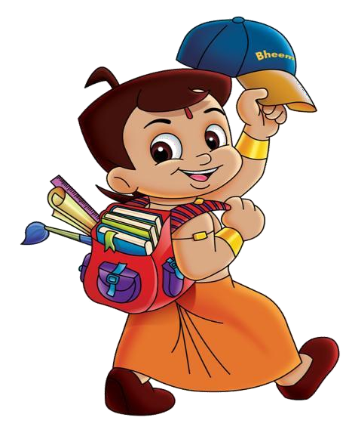greatest gifts of NATURE and your FAMILY.*

* + *Use the MAGIC WORD.......*
    - *Please*
* *Excuse Me.*
  + *Sorry*
* *Thank you*
  + *Parents are requested to only*

*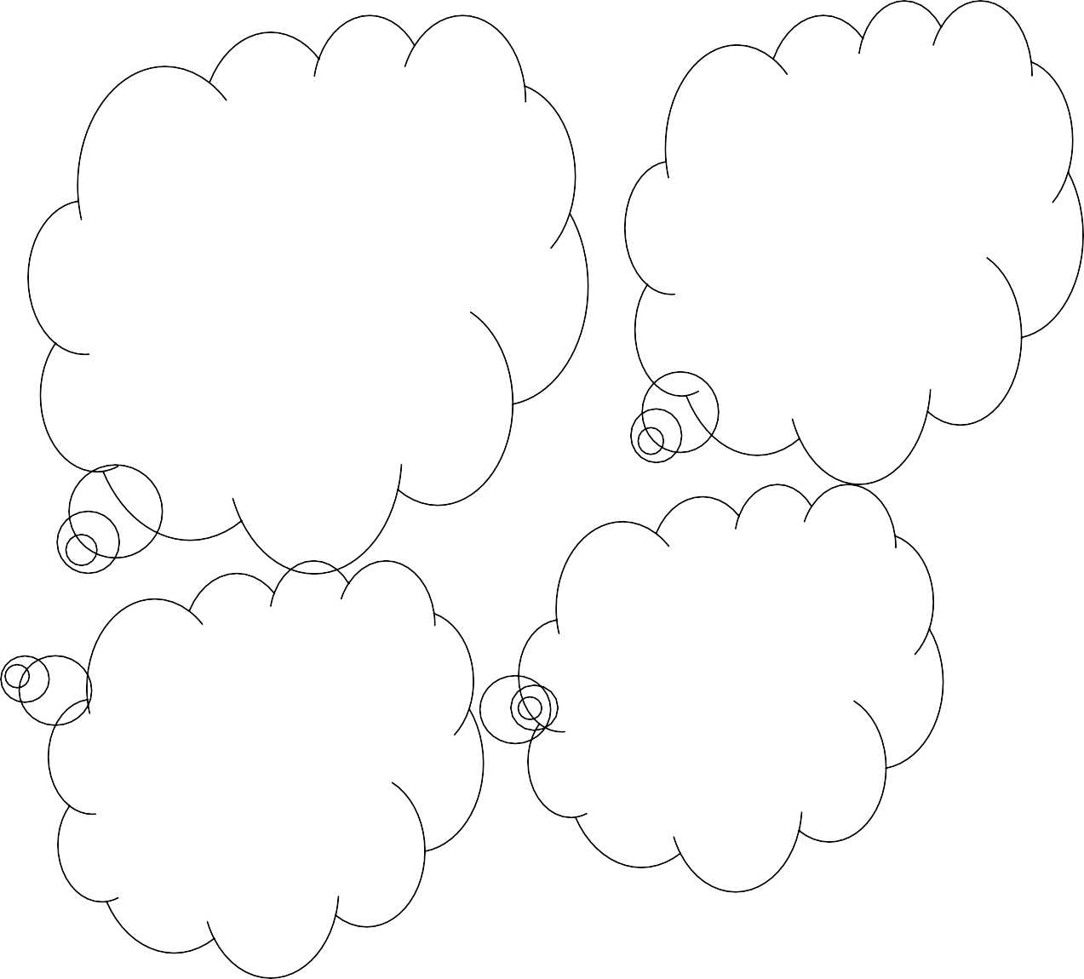guide their Children While doing the Holiday homework*

**ENGLISH -**

1. Practice daily one page Cursive Handwriting. (to be done in four lines 50 Pg. Notebook).
2. Read any one story from pdf and write difficult words. (To be done in same handwriting Notebook).
3. On the basis of the chapter "Meet My family". Read by you complete the worksheet given to you and paste in your scrapbook. (Worksheet- 1).
4. Learn the poem – My Sister’s Eating Porridge.
5. Revise all work done till date in books and Notebooks.

**HINDI -**

**1.izfrfnu ,d ist lqys[k fy[kh,A**

**2- v ls ysdj Å rd dh ek=k okys “kCnksa dk vH;kl dfj;sA**

**3- f”k{kkizn dgkuh;kW i<s+ vkSj vius NksVs HkkbZ cguksa dks lquk,A**

* **Iakpr=**
* **fodzecsrky**
* **rsukyh jkek**

**MATHEMATICS –**

1. Learn and write number names 1 to 20 (to be done in Maths 100 Pages notebook).
2. Learn table 2 to 5
3. Do the given worksheet and paste in your scrapbook. (Worksheet-4, 5 & 6)
4. Make a wall clock using material – Cardboard Sheet, Fevicol, Coloured Paper, Board Pins and Ice cream Sticks-2.

**ENVIRONMENTAL SCIENCE-**

* Good Habits and Good Deeds are essential for a Happy Life.

1. Choose any one topic from the value Education given below :-
   * I Love My Family.
   * Not Wasting Food.

* Draw a picture/click a photograph of you performing the deed.
* Paste the picture/photograph in the scrap book.

1. Do the given worksheet and paste in your scrap book. (Worksheet-7)
2. Make a beautiful Mother’s day/Father's day Card.
3. Put a bowl of water and some grains for birds observe the type of bird that come to drink water and eat grain their size, colour, tails and how they chirp (How they make sound).

**5.With the help of an elder, plant a few seeds in a small pot. Look after them well. The seeds will grow in a few days. Take the picture of plant how much it grow every week and send to your class teacher on whatsapp. Bring this pot to class and talk about it. Share how you looked after it.**

**Computer-**

Paste different parts of Computer on a scrap book.

**Art And Craft-**

Make a Photo frame or family tree with colourful papers, glitters sheet and newspaper, ice-cream sticks.

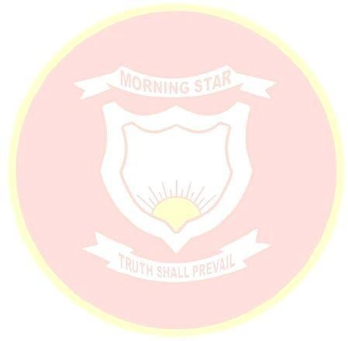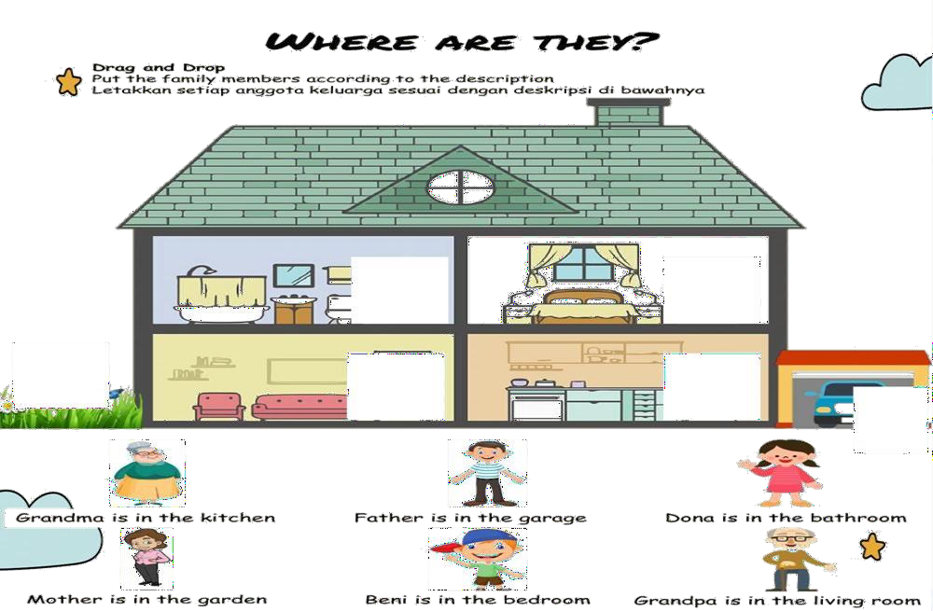

* **Xkfrfof/k**

**fcUnqvks dks feykdj fp= iwjk djks vkSj mlesa jax HkjksA**

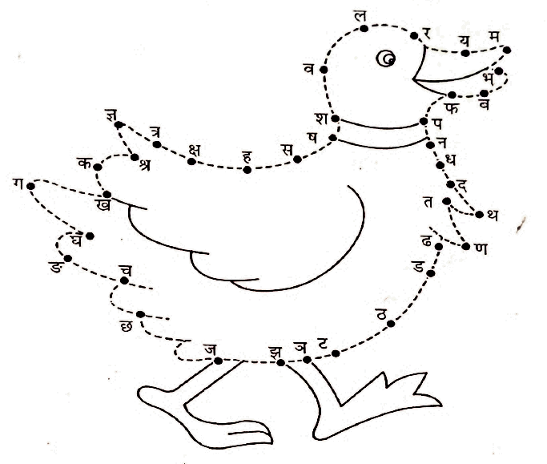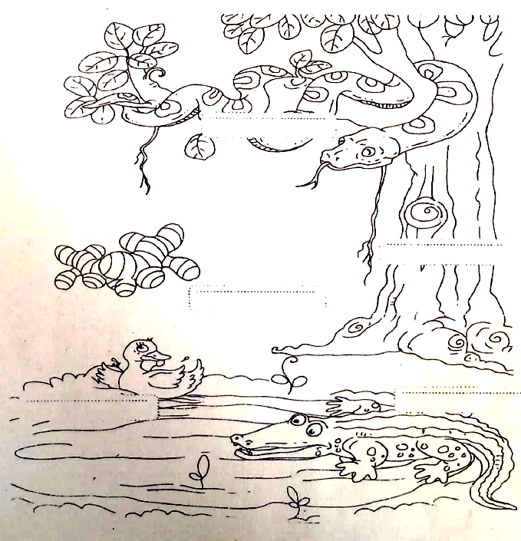

* **fp= esa jax Hkjks vkSj fp= igpkudj mudk uke fy[kksA**

## fp= igpkudj uke fy[kks

## 

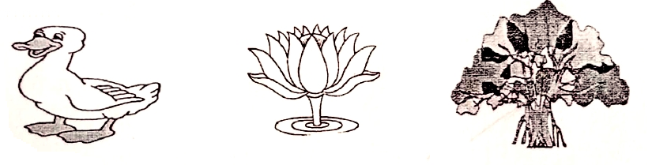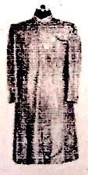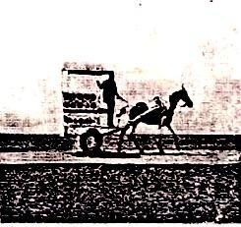

**......................... ......................... .........................**

## 

## ......................... .........................

# Join the dots from 1 to 50. Colour the picture

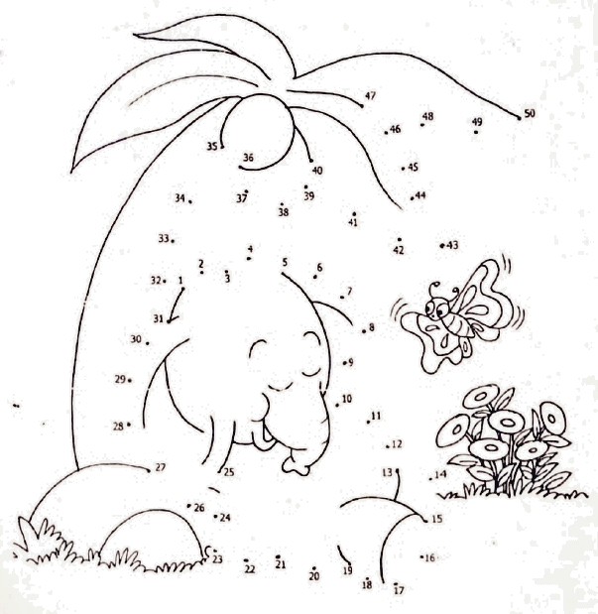

**What comes before and after**

**12**

**18**

**14**

**16**

**19**

**What comes between.**

**15**

**11**

**17**

**13**

**11**

**14**

**13**

**16**

**12**

**17**

**14**

**19**

**13**

**8**

**15**

**10**

**18**

**20**

**9**

**11**

**5**

**7**

## Numbers 1 to 50



**2**

**7**

**11**

**16**

**20**

**24**

**31 2**

**39**

**43**

**48**

**Complete the numbers from 50 to 1**

**50**

**41**

**37**

**33**

**29**

**22**

**18**

**16**

**10**

**43**

**4**

**MY SELF**

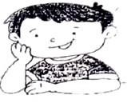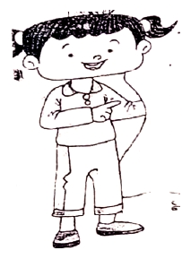

## Now, tell the about yourself

1. My Name is ...........................................

.......................

2. I am a (**boy/girl**).

Pest your Photograph Here.

3. I am .................................. years old.

1. My **mother's** name is

...........................................................

1. My **father's** name is

...........................................................

1. The name of my **school**

is ...........................................................

7. I am in **class** .......................

**section** ...........................................

## My telephone number

is .............................................................

1. My **birthday** is

on .......................................................................

10......................................................... is my best **friend**.

Our body is the most wonderful creation in the world.

**Label the parts of the body.**

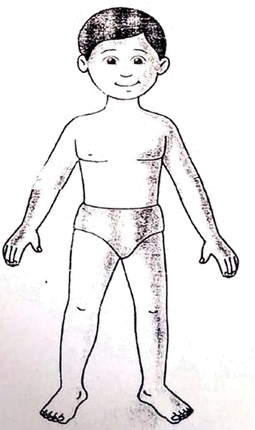

**\*ACTIVITY RECOMMENDED DURING VACATION\***

* Meditate and do simple yoga exercises .
* Water plants and feed the birds.
* Join your grandparents and parents for their morning walk.
* Help your mother in the kitchen .
* Don’t watch too much of television .
* keep your environment in surrounding clean .
* Plant trees and conserve your natural resources.
* Build and improve your vocabulary through crosswords, jumble words etc.
* Solve riddles and puzzles.
* Read story books and visit places.
* Improve your reading and writing skills by reading and writing.

**Note:**

* **Summer breaks are from 5th May to 23 June 2024. The school will**

**reopens on 24th June 2024**

***Have a great***

***Summer Vacation***